Given a Simulated health data set consisting of Age, BMI, Systolic Blood Pressure and Cholesterol levels of individuals apply cluster analysis technique to classify individuals into homogeneous group.

"wss"

Silhouette
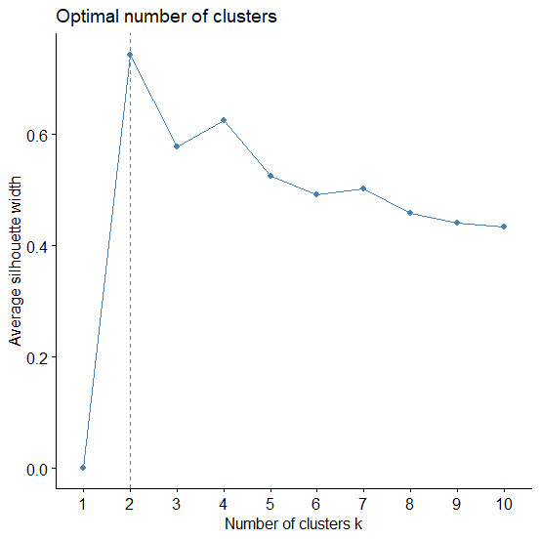

K-means clustering with 2 clusters of sizes 20, 19

Cluster means:
Age BMI Systolic_BP Cholesterol
1 25.15000 21.395 110.8500 170.1500
2 45.42105 25.900 130.9474 212.2632

Clustering vector:
[1] 1 1 1 1 1 1 1 1 1 1 1 1 1 1 1 1 1 1 1 1 2 2 2 2 2 2 2 2 2 2 2 2 2 2 2 2 2 2
[39] 2

Within cluster sum of squares by cluster:
[1] 1303.380 3088.603
(between_SS / total_SS = 85.3 %)

Available components:

[1] "cluster" "centers" "totss" "withinss" "tot.withinss"
[6] "betweenss" "size" "iter" "ifault"
